job description
personal tutor.
reports to: Director of Student Development
hours: One year fixed term (maternity cover) Full time role, term time only
salary: SP 15-18 £25,894-£28,499 (pro rata to term time only £22,139-£24,366)
start date: As soon as possible

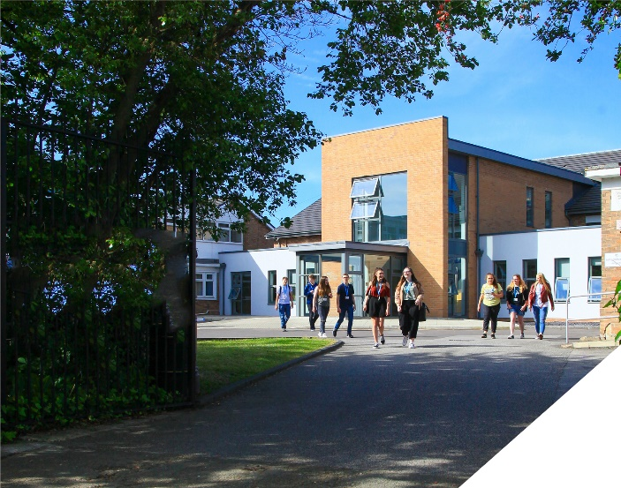
about the role.
The Student Development team is an outstanding part of an ambitious College, with highly dedicated and hardworking tutors. We are looking to appoint someone who will become an integral part of this proactive and skilled team and who will contribute to the excellent student experience. All students are allocated a personal tutor at the College. The team consists of eleven tutors and a co-ordinator – all of whom bring a broad skill-set and an enthusiasm for developing young peoples’ aspirations. There is a strong team ethos within the department and you will be fully supported by both other personal tutors and also by your line manager. This role is ideal for anyone who has the desire to make a positive impact on the lives of young people.
The Student Development team at the College are a team of dedicated and highly skilled tutors that ensure students make rapid progress whilst at the same time enjoying their studies. This therefore means the role of the tutor is very varied as students will present a wide array of differing needs and problems. You will therefore need to be able to quickly adapt to different situations and use a range of strategies to ensure students meet our expectations at College. The role entails the following: delivering weekly informative and highly relevant tutorials to each tutor group; offering advice, guidance and support to enable students to navigate College life effectively; monitoring and managing attendance and behaviour issues; liaising with parents/guardians where necessary; and preparing students for their next steps (including overseeing UCAS applications for all students). Tutors also form an integral part of the Admissions team and are responsible for interviewing prospective students at interview evenings and attending liaison activities at partner high schools (including some evenings).
about the College.
This is an exciting opportunity to join a highly successful and innovative sixth form College. The College was awarded the UK Sixth Form College of the Year by the TES in 2018 and this followed being graded outstanding in all areas by OFSTED in December 2016. All staff play a vital role in the experience that students have with us and ultimately their success.

The College currently has a 16 to 19-year-old student population of 1400 and is oversubscribed.

The College is committed to its core values of Positivity, Ambition, Resilience and Thoughtfulness, and these values shape everything we do. Our ethos is centred on the scientific evidence that tells us that everyone can achieve success through purposeful hard work as opposed to the talent myth, and as such, the College is in itself an engine for social mobility.

person specification.
Qualifications | essential | desirable
Degree or equivalent qualification | 
Careers/Advice & Guidance qualification |  | 
Experience
Minimum 12 months experience in educational (or similar) setting | 
Student guidance experience or similar | 
Effective liaison with external agencies |  | 
Knowledge / Skills / Abilities
Knowledge of progression routes for students | 
Knowledge of careers information, advice and guidance | 
Knowledge of HE | 
Excellent multi-tasking skills | 
Good organisational, administrative and presentation skills | 
Good level of IT skills, including use of: Word, Excel, Access, PowerPoint with an ability to input data accurately | 
Ability to work in fast-paced, demanding environment | 
Ability to communicate clearly and effectively | 
Ability to work with groups of young people | 
Ability to set clear targets and evaluate outcomes | 
Ability to work cooperatively with a range of people | 
Ability to work under pressure and maintain a sense of humour and perspective | 
Ability to seek positive solutions | 
Ability to work in a flexible, proactive manner and as part of a team | 
Ability to demand high standards from oneself and others | 
To demonstrate a commitment to
The Colleges values of Positivity, Ambition, Resilience & Thoughtfulness | 
Personal development and training | 
Safeguarding & promoting the welfare of students | 
Equality & diversity | 
how to apply.
If you are ambitious and determined to make a meaningful difference in one of the country’s leading sixth form Colleges then we would be thrilled to have you join our team.

- Please complete the Support Staff Application Form which is available on the College website: www.bsfc.ac.uk
- Write a Letter of Application of no more than two sides of A4 explaining how your qualifications and experience match the requirements of the Person Specification detailed above.

Please email these to: hrdept@bsfc.ac.uk

closing date: 4:30pm, Wednesday 17th August 2022

Interview date: Wednesday 24th August 2022

Application Form can be downloaded from the College website: www.bsfc.ac.uk

