job description
Teacher of Chemistry
reports to: Head of Chemistry
hours: Full time, permanent.
salary: T1-T9 £30,500- £47,133 (FTE)
start date: 20th August 2024
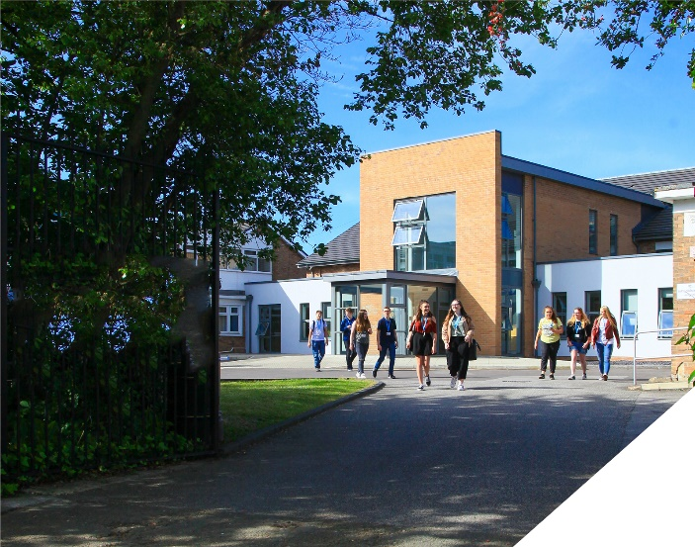
This is an exciting opportunity to teach A-level Chemistry in a thriving Sixth Form College.
about the role.
This is an exciting opportunity to join a successful Science Department at a highly regarded Sixth Form College. We seek to appoint a committed and hardworking Chemistry teacher who is keen to teach exclusively at Post 16 level. Experienced teachers and NQTs are encouraged to apply. Whatever your experience you will be supported in a way that best supports your development, in a College renowned for its innovation as well as the exceptional progress of its students.
The role is to teach A-level Chemistry, OCR Specification. There is also the need to support the delivery of other courses within the Science Department. The Science Department also offers a T-level in Science as well as BTEC Applied Science, both courses have significant Chemistry elements to them. Therefore the role will also require you to support the delivery of these courses.
The A-level Chemistry Course is a well-established course at the College which is a popular course option with over 90 students currently studying the subject. We seek to appoint a hard-working, committed Chemistry specialist who has a passion for the subject and is a positive role model for scientists of the future.
Within the department there is a real team ethos with regular opportunities for collaboration and dialogue with colleagues. The department has 8 fully equipped laboratories and has a team of 5 dedicated technicians to support with practical work and resourcing.
about the College.
You will be joining a highly successful, innovative and nationally recognised sixth form College. The College is currently College of Year awarded by Educate and has been graded outstanding in all areas by OFSTED in December 2016. All staff play a vital role in the experience that students have with us and ultimately their success.

The College currently has a 16 to 19-year-old student population of 1550. Demand for places for places at the College is very high and as a result the College has recently expanded with two new state of the art teaching blocks in September 2021. A further brand new 3 storey classroom block opened in April 2023 as part of the College’s expansion project.

In response to the pandemic and disruption to the learning of students the College introduced a new timetable in 2021/2022 to combat the deficits that students have. This includes teaching time increasing by 60 minutes each week we are confident that the 5.5 hours students receive each week is one of, if not the highest in the country. Whilst student teaching time has increased the new timetable has reduced the overall teaching time for teachers each week. Full time teachers will teach a maximum of 4 classes, 4 times a week and teachers have their own groups, we do not have shared teaching groups at the College.

The College is committed to its core values of Positivity, Ambition, Resilience and Thoughtfulness, and these values shape everything we do. Our ethos is centred on the scientific evidence that tells us that everyone can achieve success through purposeful hard work as opposed to the talent myth, and this enables learners to make rapid progress unshackled by any limits previously placed upon them.

person specification.
Qualifications | essential | desirable
Degree in a Chemistry related discipline | 
Qualified Teacher Status | 
Experience
Experience of teaching A-level Chemistry | 
Experience of teaching BTEC Applied Science |  | 
Experience of working as an examiner for Chemistry |  | 
Experience of working in a demanding environment where high levels of organisation are required | 
Knowledge / Skills / Abilities
Ability to teach A-level Chemistry | 
Up to date knowledge & understanding of the OCR Chemistry specification | 
Ability to work flexibly as part of a team | 
Ability to form & maintain appropriate relationships & personal boundaries with young people | 
Ability to respond flexibly & creatively to new challenges & opportunities | 
Ability to prioritise & meet deadlines | 
Ability to use Information Technology effectively | 
Excellent communication, interpersonal & organisational skills | 
To demonstrate a commitment to
The Colleges values of Positivity, Ambition, Resilience & Thoughtfulness | 
Personal development and training | 
Safeguarding & promoting the welfare of students | 
Equality & diversity | 

how to apply.
If you are ambitious and determined to make a meaningful difference in one of the country’s leading sixth form Colleges then we would be thrilled to have you join our team.

There are 3 parts to your application please ensure you submit all three to be considered:-

- Complete Application form
Please complete the Teacher Application Form which is available on the College website: www.bsfc.ac.uk

- Summarise your results
Please submit a summary of the last 3 years of examination results this can be included in the appropriate section in the application form or as a separate document (if appropriate – if you are an NQT please skip this part of the application procedure)

- Complete personalised questions
On a separate document, answer the following specific questions (each question should be answered separately with each answer being no more than 150 words):

- Aside from your stated qualifications, please outline what you believe makes you academically suited to the position applied for.
- The College does not currently operate a gifted and talented programme. What is your view on this approach?
- Please identify one or two skills or techniques you have used in the classroom to drive learning.
- Select one of the College values and describe ways you demonstrate this in your day to day work.
- You should have provided an accompanying sheet summarising the results you have achieved over the last three years. Is there any context or background you would like to give to these?

Please email these to: hrdept@bsfc.ac.uk

closing date: Midday on Thursday 9th May 2024

Application Form can be downloaded from the College website: www.bsfc.ac.uk

General Information
Birkenhead Sixth Form College has a commitment to safeguarding and promoting the welfare of students and expects all staff and volunteers to share this commitment. If you are invited for interview, your suitability to work with children will be explored as well as your suitability for the post.
All posts are subject to Enhanced Disclosure Clearance through the Disclosure & Barring Service.
The College is an Equal Opportunities employer and all members of the College have a personal responsibility to implement the policy, to carry out their responsibilities in accordance with it and to maintain an equality of opportunity for all.
The Governors and staff of the College take their duties under the Disability Discrimination Act (as amended by the Special Educational Needs Act 2001) very seriously. They will ensure that all reasonable adjustments are made to ensure that disabled people are treated fairly and that they are not placed at any substantial disadvantage. The College is committed to interview all applicants with a disability who meet the minimum criteria for the post and to consider them on their abilities.

Reference Checking

On the application form, you are asked to provide details of two employment referees (preferably your line manager from your current and previous or most recent employer/s), who can comment on your suitability for the post. References from relatives or individuals writing in the capacity of friends will not be accepted.

The College will seek references on short-listed applicants before interview, and will approach previous employers for information to verify suitability for the post, dates of employment, particular experience or qualifications, attendance / punctuality history and details of any disciplinary offences.

In addition, if you are currently working with children or young people, on either a paid or voluntary basis, your current employer will be asked about your suitability to work with children and any disciplinary offences relating to children or young people. This will include any offences for which the penalty is time expired (that is where a warning could no longer be taken into account in any new disciplinary hearing for example) and whether you have been the subject of any child protection concerns, and if so, the outcome of any enquiry or disciplinary procedures. If you are not currently working with children but have done so in the past, that previous employer will be asked about those issues. Please note providing false information is an offence and could result in your application being rejected, or dismissal without notice if you have been appointed and possible referral to the police.

