20th March 2020

Dear Students,

Information for Final Year Students

As I am sure you are all aware the Government have announced that schools and colleges will close from Monday 23rd March as part of the country’s ongoing response to coronavirus. In addition to this they also confirmed that exams scheduled for this summer will not go ahead.

The physical college may be closed to staff and students until further notice but studying and learning will very much continue. Your teachers will be setting you regular work for every lesson to complete by a variety of means including via e-mail, Microsoft teams, Moodle and other possible online platforms.

Your studies

- Check your college e-mail daily for work instructions from your teacher
- Complete the assigned activities
- Submit work as instructed by your teacher by the deadline
- The completion and engagement with this work will contribute towards your college forecast grades in April and June.
Your grades

- The Government are due to release the exact details of how your final grades in your courses are arrived. However it will be largely based on our assessment of you and this also includes what you do from now until the end of the course.
- We have been collecting your forecast grades as a college since October during your first year and additional forecasts will be made in April and June.
- Further details will be released once we have received clarification from the Department for Education.
I appreciate recent events are very unsettling and disappointing for you all, however your hard work has not gone to waste as you all have developed useful skills and knowledge that will help you in the future. The work you have completed and are still to complete will enable us to ensure the final awarding of grades is fair and accurate. It is also important that your studies continue so that you are fully prepared for your next phase of learning.
If you have any concerns or queries regarding any matters detailed above please contact your personal tutor.

Yours sincerely

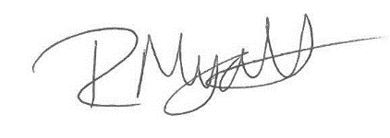

Rob Myatt
Deputy Principal

