Libraries Week Book Quiz
Can you match the first lines of these popular books to their titles and authors?

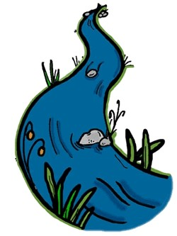
“Mr and Mrs Dursley, of number four, Privet Drive, were proud to say that they were perfectly normal, thank you very much.”

“Alice was beginning to get very tired of sitting by her sister on the riverbank, and of having nothing to do: once or twice she had peeped into the book her sister was reading, but it had no pictures or conversations in it, ‘and what is the use of a book’, thought Alice, ‘without pictures or conversation?’”

“We slept in what had once been the gymnasium.”

“When I wake up, the other side of the bed is cold.”

“ “We should start back,” Gared urged as the woods began to grow dark around them.”

“Emma Woodhouse, handsome, clever, and rich, with a comfortable home and happy disposition, seemed to unite some of the best blessings of existence; and had lived nearly twenty-one years in the world with very little to distress of vex her.

“Mr Sherlock Holmes, who was usually very late in the mornings, save upon those not infrequent occasions when he stayed up all night, was seated at the breakfast table.”

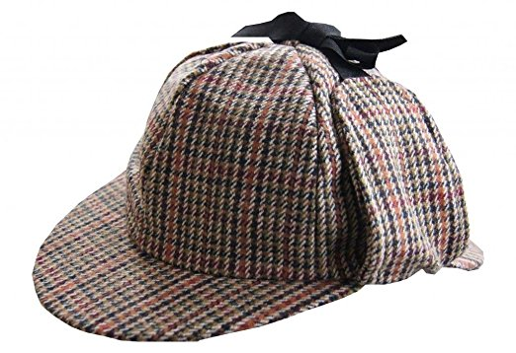

“It was a pleasure to burn.”

“In my younger and more vulnerable years my father gave me some advice I’ve been turning over in my mind ever since.”

“This book was born as I was hungry”

“When Mr. Bilbo Baggins of Bag End announced that he would shortly be celebrating his eleventy-first birthday with a party of special magnificence, there was much talk and excitement in Hobbiton”

“Late in the winter of my seventeenth year, my mother decided that I was depressed, presumably because I rarely left the house, spent quite a lot of time in bed, read the same book over and over, ate infrequently, and devoted quite a bit of my abundant free time to thinking about death.”

“When he was nearly thirteen, my brother Jem got his arm badly broken at the elbow.”

“Lyra and her daemon moved through the darkening Hall, taking care to keep to one side, out of sight of the kitchen.”

“I write this sitting in the kitchen sink.”

“The boy with fair hair lowered himself down the last few feet of rock and began to pick his way toward the lagoon.”

Please write down your name and hand in at the Hub Desk to be added to the prize draw!

